**SCIENTIFIC COMPUTING**

## ASSIGNMENT 4 *TUSHAR SIRCAR 130123038*

1. SOURCE CODE:

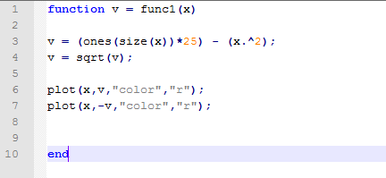

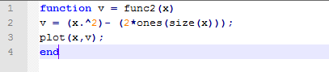

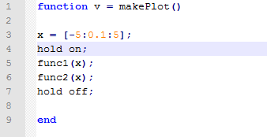

C:\Users\tushar\AppData\Local\Microsoft\Windows\INetCache\Content.Word\functionPlot.emf

From graph, solution to the two equations is -2.5 and 2.5.  
Two root are imaginary!

1. SOURCE CODE  
   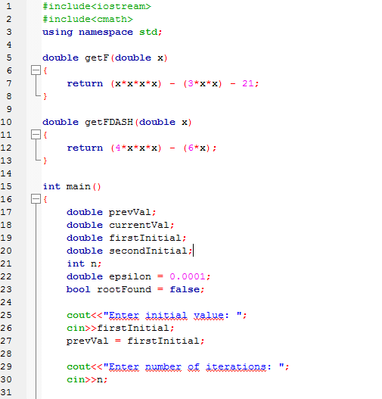

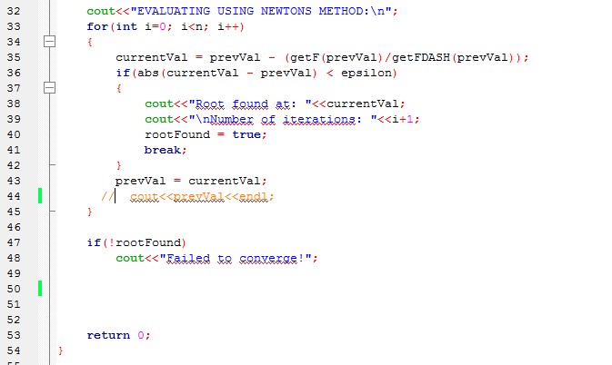

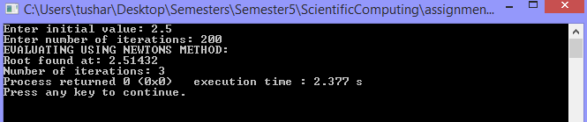

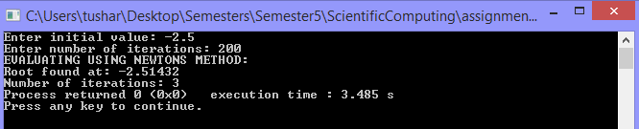

NEWTONS METHOD  
Initial Value: 2.5  
Root Found: 2.51432  
Number Of Iterations: 3  
  
NEWTONS METHOD  
Initial Values: -2.5  
Root Found: -2.51432  
Number Of Iterations: 3

(b). SOURCE CODE

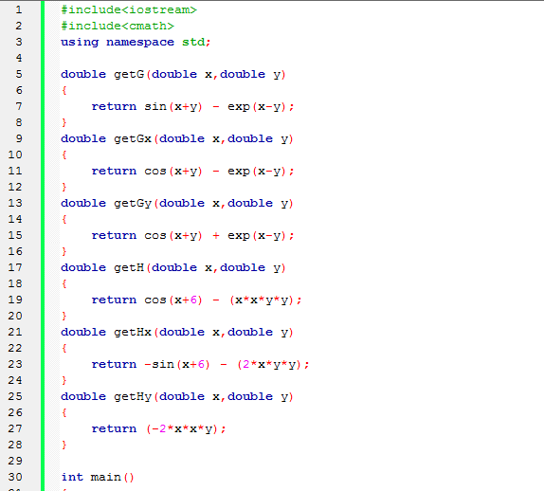

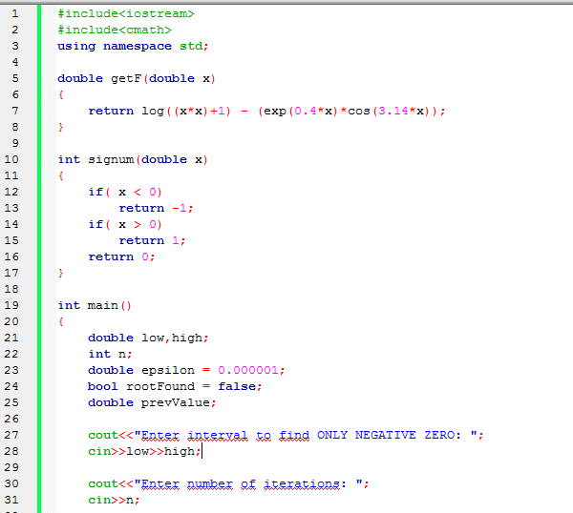

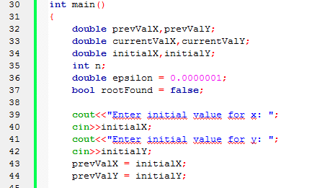

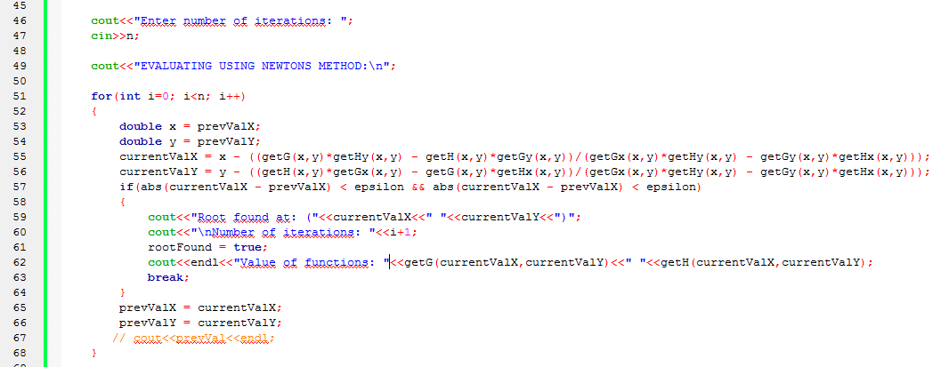

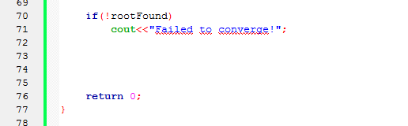  
  
Using Cauchy Rimeanns equation and using Newtons Method for complex numbers as given in ques 4, we get the following result:

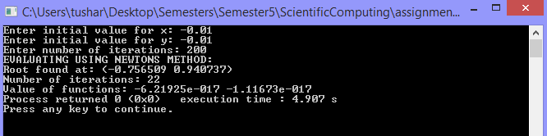

Root Found At: (-0.756509,0.940737) that is -0.756509 + 0.940737i

Number Of Iterations: 22

1. SOURCE CODE

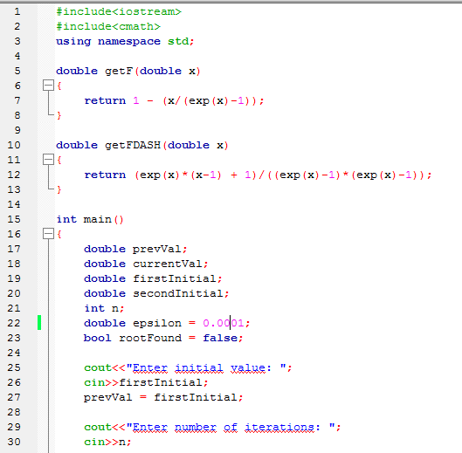

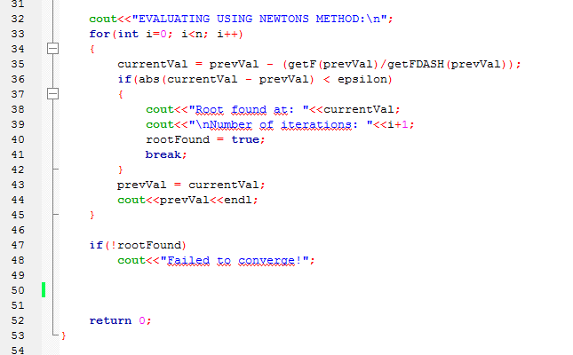

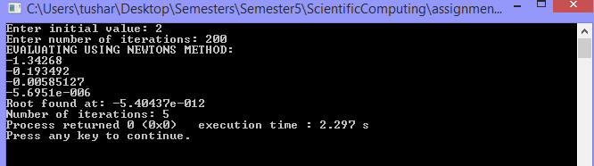

Root Found At: -5.40437*exp(-12)

Number Of Iterations: 5

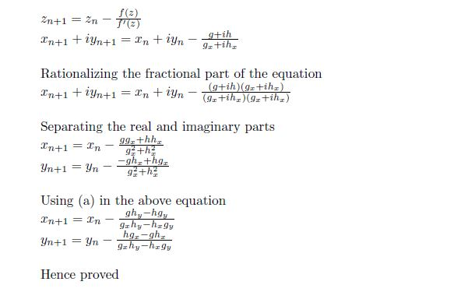

1. (a)

SOURCE CODE

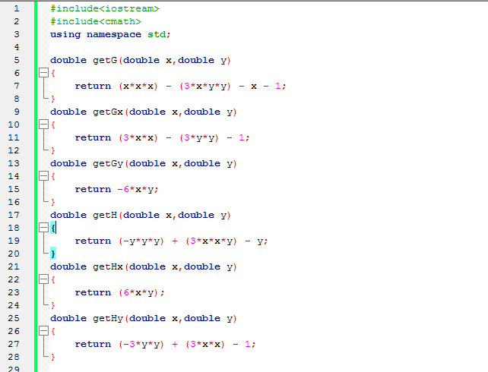

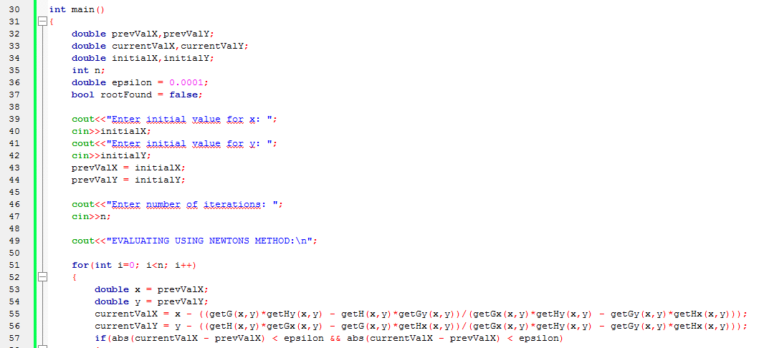

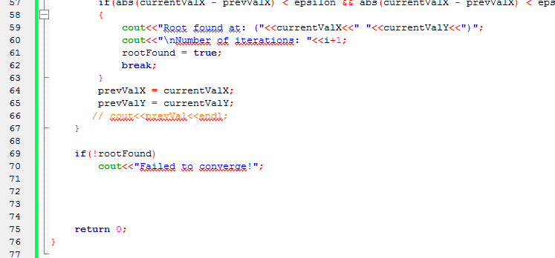

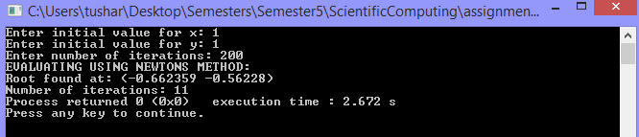

Root Found At: (-0.662359,-0.56228) that is -0.662359 -0.56228i

Number Of Iterations: 11

1. SOURCE CODE  
   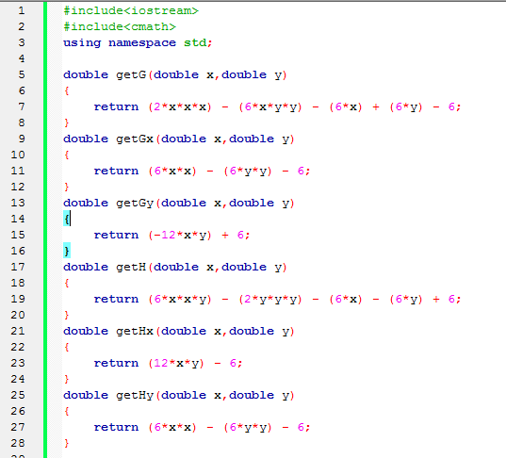

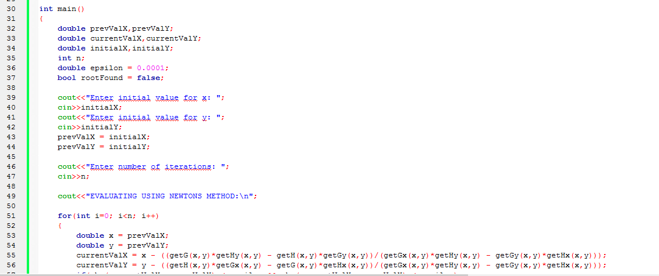

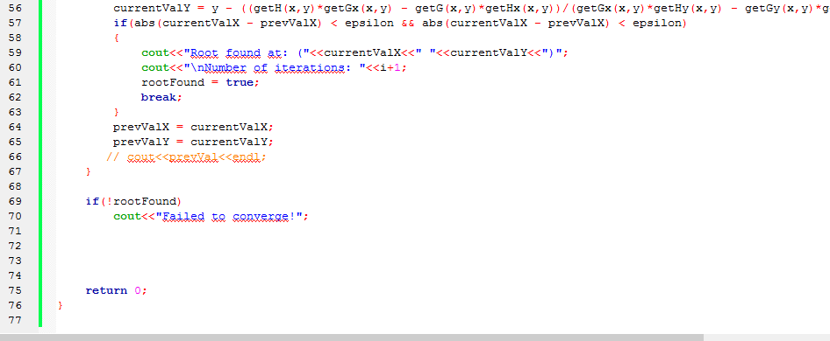

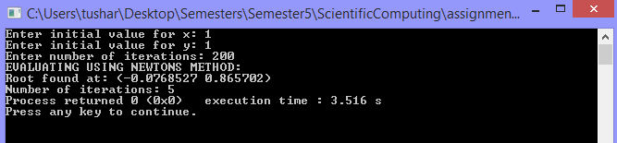

Root Found At: (-0.0768527,0.865702) that is -0.0768

Number Of Iterations: 5